DEP Task 3: Developing Product Descriptions

In this task, I mentioned a fictional e-commerce business website. It includes 3 product names and their description along with suitable images

# Company Name: **AuraGlow**

**1**

## **AuraGlow Skin Revitalizing Serum**

Revitalize your skin with a burst of natural hydration and say goodbye to dull, tired complexions. AuraGlow Skin Revitalizing Serum is packed with a blend of antioxidant-rich botanical extracts and hyaluronic acid, delivering deep nourishment to replenish moisture and restore your natural glow.

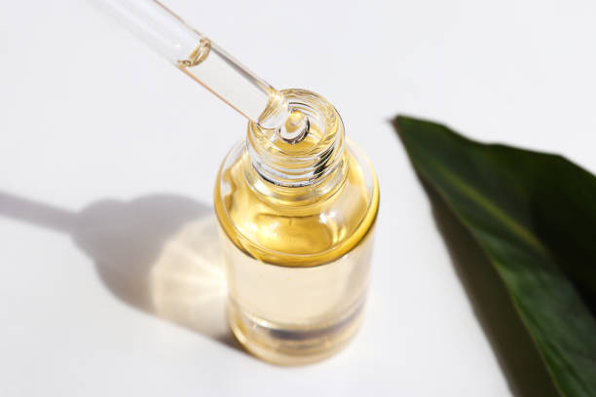

### **Key Ingredients**

* Hyaluronic Acid: Deeply hydrates and plumps skin.
* Vitamin C: Brightens and evens out skin tone.
* Green Tea Extract: Rich in antioxidants that protect skin from environmental stressors.

### **Benefits**

## Hydrates your skin

* It fades dark spots and discoloration, leaving you with a radiant complexion
* Smooths and refines skin texture for a soft, velvety feel

Whether you have dry, oily, or combination skin, AuraGlow Skin Revitalizing Serum is the perfect addition to your daily routine. Embrace the power of nature and let your skin shine with this nourishing serum.

*Add AuraGlow to your skincare routine today!*

**2**

## **AuraGlow Natural Lip Balm**

Experience long-lasting moisture with AuraGlow Natural Lip Balm, crafted from 100% natural ingredients like beeswax, coconut oil, and shea butter.   
This luxurious lip balm creates a protective barrier, locking in moisture and leaving your lips soft and smooth.

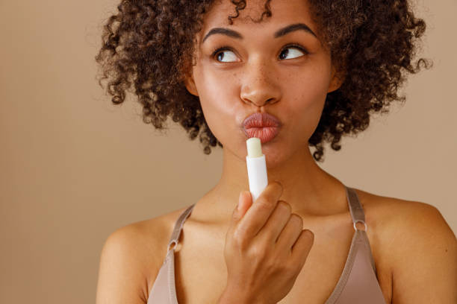

### **Key Ingredients**

* Organic Beeswax: Forms a protective layer to seal in moisture.
* Shea Butter: Deeply hydrates and conditions lips.
* Coconut Oil: Provides antioxidant protection and a natural shine.

### **Benefits**

* It gives your lips deep hydration
* Protects chapping
* Impart a healthy, glossy finish

### **Flavors to Suit Your Mood**

AuraGlow Natural Lip Balm is available in three delightful flavors:

* Refreshing Mint
* Comforting Vanilla
* Fruity Berry

*Give your lips the love they deserve and try AuraGlow Natural Lip Balm now for soft, hydrated lips—naturally.*

**3**

## **AuraGlow Anti-Aging Moisturizer**

Fight the signs of aging with AuraGlow Anti-Aging Moisturizer, a powerful yet gentle formula designed to reduce wrinkles and promote firm, youthful skin.

### **Key Ingredients**

* Peptides: Stimulate collagen production to improve skin texture and elasticity
* Retinol: Accelerates cell turnover and boosts collagen, minimizing signs of aging.
* Hyaluronic Acid: Deeply hydrates and plumps skin.

### **Benefits**

* Reduces Fine Lines and Wrinkles
* Firms Skin
* Boosts Collagen
* Non-Greasy Formula for Day or Night Use

AuraGlow Anti-Aging Moisturizer absorbs quickly into the skin without leaving a greasy residue, making it ideal for day and night use.

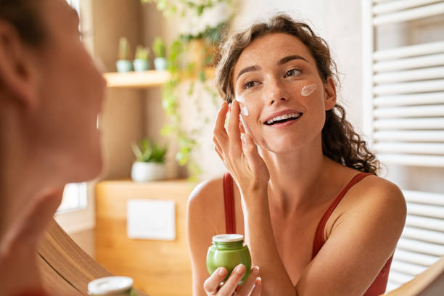

*Restore your skin's youthful glow with this powerful yet gentle moisturizer*